Wellington Women’s
Refuge
Annual Report

1st April 2011 – 31st March 2012

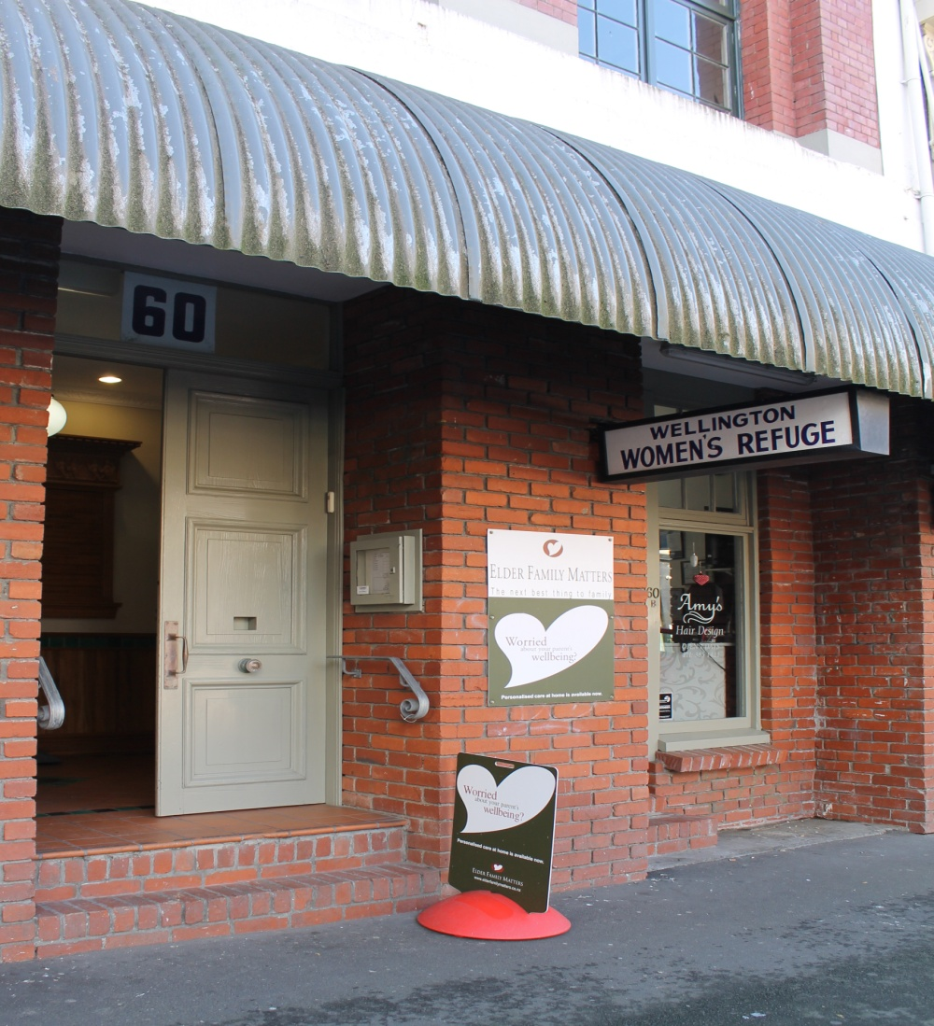

Community Office, Level 3, 60 Ghuznee Street.

Table of Contents

Organisational overview 3
Support and Advocacy-
Community Services__________________________________________________3
Safe-house Services___________________________________________________4
24/7 Crisis Line__________________________________________________________________________________6
Education Programmes_________________________________________________________________________6
From a woman who has used our services_____________________________________________________7
Statistics_____________________________________________________________________________________8-12

Collaboration__________________________________________________________________________________13
Report from our Volunteer Coordinator_____________________________________________________14
Report from our Staff Support Manager____________________________________________________15
Report from our Treasurer _______________________________________________________________16-17
Fundraising____________________________________________________________________________________18
Acknowledgements________________________________________________________________________19-20
Future Directions 2012/2013_________________________________________________________________21

Organisational Overview

This is our 34th year providing services to women and children in the Wellington Community. We work alongside our sister Refuge Te Whare Rokiroki who provide services to Maori women and children. Our services are confidential and we support women whether they choose to leave or stay in a relationship. We work in a holistic way with survivors of domestic violence; advocating in all areas that affect a woman’s situation, referring as needed to other specialist organisations and walking alongside and empowering her to make safe decisions for the future.

Vision: All women & children living free from fear and violence.

Mission: Intervention, Prevention and Advocacy for all women and children experiencing domestic violence.

Who: We work with women and their children who have experienced or who are experiencing domestic violence. Domestic violence involves one person dominating and controlling another person in a relationship. This can include a range of power and control tactics and may not always involve physical violence; the abuse does not have to be physical violence for someone to access our service. The women we work with are from a range of ages, ethnicities, sexual orientations, and socio-economic backgrounds.

Where: The area we cover is Wellington city and surrounding suburbs up to but not including; Newlands/Johnsonville which is covered by Porirua Refuges and Petone which is covered by Hutt Refuges.

How: Wellington Women’s Refuge provides support, information and advocacy to survivors of domestic violence; walking alongside and empowering them to make safe decisions for their future. We believe in women making their own decisions and don’t put pressure on them to take steps they are not ready to or don’t want to. We will refer to other agencies as required and advocate with services such as police, lawyers, courts, housing, Work & Income. We provide women and their children with the option of a safe place to stay, and also support women and their children in the community. We operate a community office and a 24 hour crisis telephone line assisted by a roster of volunteers responding to the crisis line outside working hours.

Structure: We operate under a collective structure made up of paid and volunteer advocates. Our team of 8 paid staff are co-ordinated by our Staff Support Manager and our team of around 20 volunteers are co-ordinated by our Volunteer Coordinator. Within our collective we have subcommittee’s (these include employment, finance, volunteer, fundraising and political); these subcommittees have delegated roles on which they report back to the collective. Because we recognise the abuse of power as a root cause of violence our organisational values are based on an anti-oppression philosophy.

How to refer: We are a free and accessible service; we don’t have waiting lists for our crisis and social work support services. We take self referrals as well as those that come from other people such as agencies, police, family and friends. To make a referral simply phone the crisis line or office.

Support & Advocacy Services
Community Services

Our community office based in Cadbury House, 60 Ghuznee St is open 9-5 weekdays. The office is easily accessible to clients and is a base for enquiries from the public, support work with clients, meetings, education and programme work.
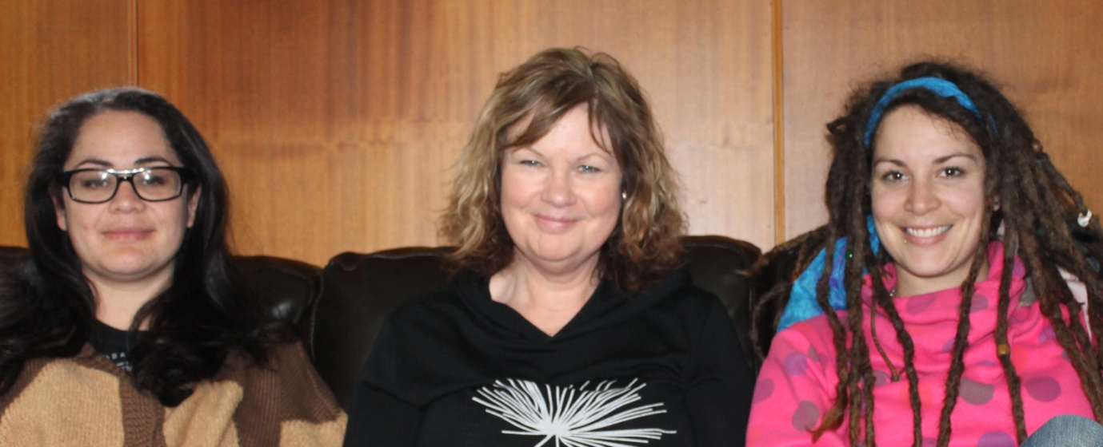
Our three community social workers Kyla Lyons, Rita Harris and Hayley Burns

Over the past year, Wellington Women’s Refuge has supported 210 women and 256 children as community clients; this is on a par with the previous year for women and a slight increase for children. Our social workers carry high workloads with a steady demand for service. Our community clients may still be in an abusive relationship, have somewhere safe to stay, have come out of the safe-house, or the focus may be on remaining safe in their homes. Community clients are still very much in need of crucial ongoing support and advocacy.
The service provided to these clients includes a nonjudgmental and confidential listening ear, information, referrals and safety planning. Also provided is support and advocacy with other agencies such as police, lawyers, housing, Work & Income, and support through the court process.
The families we work with represent a diverse group of women and children from a variety of socio-economic and cultural backgrounds. These families show immense bravery and strength during a stressful and often traumatic time in their lives. The majority of families who access Wellington Women’s Refuge do so through self-referrals and many are reaching out for the first time.
Community Client feedback forms 2011:
“I was very afraid to come and put it off for a long time but was pleasantly surprised at how good the service was. It was a lot better than I expected and I would totally recommend it”
“I hadn’t realised how much I needed to talk to someone until I got there”
“My assigned worker was very swift to get me all the services that I required”

“I didn’t want to go into a safe-house so they were really supportive of helping me stay in my own home”

“They were non-judgmental and welcoming and they followed up”
Safe-house Services

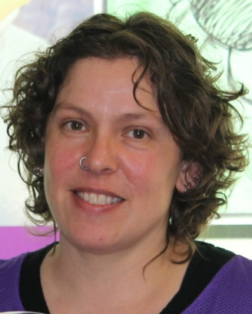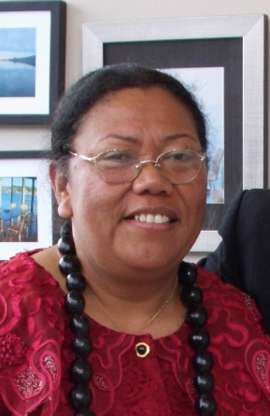
Kay Flude Safe-house Coordinator Milika Telefoni Safe-house Worker
The Wellington Women’s Refuge safe-house is a residential home at a confidential location where women and their children who are escaping domestic violence can be safe while they plan for their future. Coming into the safe-house is a huge and often frightening step and women can feel safe in the knowledge that their safety is our top priority and that their choices regarding their future will be listened to and respected.
During the year 2011/2012 we supported 53 women and 53 children in our safe-house. The average stay was 15 nights per family. These statistics are a slight decrease from the previous year and indicate an ongoing leveling out in the demand for our safe-house service. After the dramatic increases we faced 4-5 years ago we are relieved to have these services operating at a sustainable level where we most often have bedrooms available as needed rather than being under pressure to squeeze families into the living area.
We provide information, support, and advocacy to all families during their stay with us and this support carries on once the family returns to the community for as long as it is required. Thanks to generous donations from the public we are often able to assist families with furniture, bedding and other household items for their new home. This can make a significant difference to a family that may have had to leave their home with few of their belongings.
Kay Flude our Safe-house Coordinator and Milika Telefoni, who helps keep the house and garden tidy and well-organised, have both worked tirelessly over the last year to provide a welcoming atmosphere along with ongoing support to all women and children staying in the safe-house.

Safe-house client feedback forms 2011:

“it was very homely for me and my children”

“nice and safe, clean and spacious, gave me a bit of time out from what I was going through”

“I appreciated having my own bedroom that was quiet and private”

“Kay was very supportive to me all the time and in court too, I appreciate that…. The life which I have now is very different to the one I had before. I feel much better and my son has changed a lot”

24/7 Crisis Line

Wellington Women’s Refuge operates a 24/7 crisis line. Our crisis line is available 24 hours a day / 7 days a week, 365 days of the year. This is a vital service as accessibility is a must for women in domestic violence situations who may have limited opportunity to ring or need crisis support outside of working hours.

Women seeking support can ring our landline number or the 0800REFUGE national calling number, responding to the prompts to come through to their local Women’s Refuge service. With the shift towards cell phones rather than land-lines it is reassuring to know that lack of credit on a phone will not prevent a woman from getting through.

We continue to provide a shared crisis line with our sister Maori Women’s Refuge, Te Whare Rokiroki. During the working day the crisis line comes through to the two individual Refuges, after-hours the two Refuges share a crisis line with volunteers from both Refuges sharing rosters and taking calls on behalf of either Refuge. This collaboration means a sharing of resources to work together for all women needing domestic violence support in the Wellington Community.

Our crisis line offers a ‘non-judgmental ear’ for women facing domestic violence situations and also offers support, information & advocacy when requested. Paid workers staff the crisis line during working hours and volunteers overnight, during weekends and public holidays. Our volunteers work from their homes, with an answering service connecting the phone calls through to their own phone. We are dependent on the huge number of hours donated by voluntary staff. Most women contact us through our crisis line or community office. Others come to us via police, lawyers, Work & Income, health, and community workers. Sometimes a friend or family member of a woman experiencing family violence may call our crisis line for information.

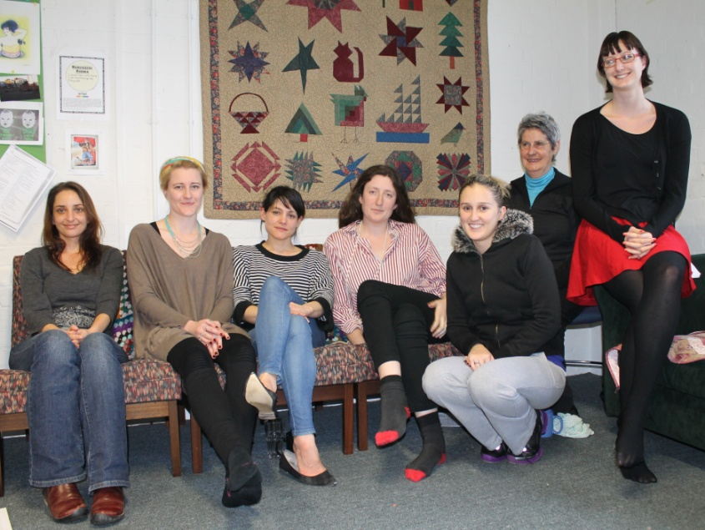
Seven of our dedicated crisis-line volunteers
Faye Drawneek, Jess Lee, Jess Mills, Emma White, Anna Thomson, Elaine Lynskey, Cara Thornburn

Education programmes

Community education has continued to be a focus for Wellington Women’s Refuge as part of our commitment to preventative as well as crisis work in the field of domestic violence.

Community education: We hold domestic violence education sessions which are low-cost and open to anyone in the community. These sessions teach practical skills for recognising and responding to domestic violence and explains the principles of safety planning and legal protections. Feedback from attendees has been that they have found these sessions extremely useful. We also continue to deliver external training on request.
We have offered 11 community education sessions in past financial year, both from our office in central Wellington but also in community centres in Strathmore and Newtown. We also delivered our first government department training, delivering a 6 session module training to MSD covering aspects of domestic violence, policy and developments in the domestic violence field. We have also done preventative work through schools such as Wellington East Girls and Onslow Colleges. Over the year we have provided training to over 200 people from over 50 different organisations and agencies.

Tamariki Programme: this is a 10-session programme for 5-8 year olds focusing on what abuse looks and feels like, keeping safe and involving parents in developing positive communication skills for sharing feelings. Kay Flude is co-ordinating this programme alongside co-facilitators from Wellington Women’s Refuge and Te Whare Rokiroki. Our staff find this work rewarding and parents are reporting positive changes.

Women’s programme: we are thrilled to now have up and running this 16-session therapeutic education programme for survivors of domestic violence. It supports women to understand the impacts of abuse, rebuild self esteem and set goals for the future. Eleanor Butterworth has put much time and effort into developing this programme and gaining Ministry of Justice approval and funding. She is now co-ordinating the programme alongside co-facilitators from Wellington Women’s Refuge and Te Whare Rokiroki. Please see the next page for a testimony from a woman who has come through this programme.

Evaluation results from our first Women’s Programme:
Area: | Percentage agreeing the programme had positive impacts or improved ability and skills in these areas:
Improvement in parenting and understanding of impact on violence on children | 85% Agreed or Strongly Agreed
Improved ability to talk to children about violence and abuse | 100% Agreed or Strongly Agreed
Improved safety and safety planning | 100% Agreed or Strongly Agreed
Improved understanding of sexual abuse and healthy sexual relationships | 85% Agreed or Strongly Agreed
Increased positivity about the future | 100% Agreed or Strongly Agreed
Improved confidence, self esteem and ability to make positive choices | 100% Agreed or Strongly Agreed

From a woman who has used our services

I am so grateful and appreciative of the help, support and resources that the Women’s Refuge have provided for me, during a crisis period with my ex-partner when he became emotionally and psychologically abusive.
As an academic with a PhD, I am part of a cultural and socio-economic class where domestic violence is not recognized or acknowledged as an issue. As an immigrant from the US without any family in the country, I also felt alone and isolated. Although I had some friends (though I had lost many through the isolation that I experienced in the preceding years, also as a result of the abuse), I did not feel comfortable sharing these traumatic and terrifying experiences. When I finally did break down, my doctor sent me to see a therapist. It was really useful to work with my therapist to recognize the abuse, and to help me determine the safest way of extricating myself and my children from this increasingly scary relationship. But, it was the emotional support and practical help of the Women’s Refuge that gave me the courage and strength to leave.

From the moment I rang their number, I was instantly put in contact with a support person who was there helping me every step of the way. Although my therapist helped me understand objectively the experiences I was going through, the Women’s Refuge helped me cope with the emotional and mental experiences that I survived – that first-person, subjective perspective, that understanding of what it feels like to experience abuse in a day-to-day environment, was crucial to being able to cope during those many months.

I was also lucky enough that shortly after the Refuge helped me leave my partner, they ran courses for myself and the children to transform victims into survivors. I saw immediate emotional changes in both my children, and also in myself, as we went through those courses – they were invaluable for us to process the experiences we had suffered, and to be able to gain the confidence and emotional skills that we needed to move forward in our lives. Even now, about a year later, I am still in close contact with the women with whom I took this course – this too has been facilitated by the Refuge. Because the process of recovery from abuse (which had happened over the course of several years) is itself a long-term process, I think I have been able to move forward more quickly, and to regain my self-confidence more quickly because of all of the support the Refuge has provided. And, again, because domestic violence is a taboo issue that is not accepted as occurring in my socio-economic group, the Refuge support has been one of the only places where I can feel comfortable talking and sharing and moving forward.
For these reasons, I will always be a strong supporter of the Wellington Women’s Refuge, and hope that its resources will be able to help others like me. The help the Refuge provided truly changed my life, and the life of my children, in a radical and profound way. It has been perhaps the most transformative experience I have ever had, and I could not have done it without them.

Statistics 1st April 2011 – 31st March 2012

Clients by Age
(Community & Safe-house)

Women: As the graph below shows, the age group of women accessing our services is relatively evenly spread dropping off slightly in the 46-59 year age group and this year dropping off dramatically to 0% in the 60+ age group. Often for elderly women experiencing abuse we will refer on to Age Concerns elder abuse service for a more specialised service.

Children: The three age groups under age 16 relate to children of the women accessing our services and these are also relatively evenly spread with 10-16 the highest, dropping slightly for the 0-4 age group and 5-9 respectively.

Figure 1: All clients by age

Clients by Ethnicity (Safe-house)

Women and children: The graph below indicates the ethnicity of women and children accessing our safe-house service during the period. We have continued to have the largest portion of Pasifika clients in our safe-house over the last year at 37%; this is followed by Maori at 24%, Pakeha at 18%, the next largest group being Other Ethnicity at 10%, followed by Asian at 8% and European at 3%. The Maori total includes Maori children of non-Maori women in our safe-house and also clients of Te Whare Rokiroki, Maori Women’s Refuge for whom we provided a place when their safe-house was full.
This graph does not fully illustrate the ethnic diversity of women accessing WWR services as our current database fits ethnicity into these 6 categories. Women and children supported who come under the category of ‘Other Ethnicity’ in this period include; Middle Eastern, African and Latin American.

Figure 2: Residential clients by ethnicity

Clients by Ethnicity (Community)

Women and Children: The largest group of community clients are Pakeha at 45%, followed by Pasifika at 17%, Asian at 12%, Other Ethnicity at 11% and Maori at 9%. The Maori total is mainly made up of Maori children of non-Maori women who are community clients. This graph differs from safe-house ethnicity statistics with the total of Pakeha being supported in the community more than double of those being supported in our safe-house and the number of Pasefika being less than half that being supported in the safe-house.

The group titled ‘Other Ethnicities” is made up of various ethnicities including Middle Eastern, African and Latin American. We hope to have a change in our database to record these ethnicities individually so our data better reflects the ethnic diversity of the women we support.

Figure 3: Non-residential clients by ethnicity

Clients by Referral Source (Safe-house)

26% of women entering our safe-house were referred by our own service as they were already being supported as community clients. The safe-house can be a positive step for women on the journey towards living free from domestic violence.

Another 26% of women entering our safe house were self referred; self referrals remain the highest source of women first coming into our service. Women coming into our safe-house service via police referrals total 18% this is made up of 15% of referrals come direct from the police at the time of a domestic violence incident or a woman seeking assistance from police and a further 3% come from police via a pol400 referral (police report of a domestic violence incident which is later followed up by us).
Family members or friends refer 8% and under this come various other referral sources to our safe-house service such as Doctor, other Refuges, or the hospital.

Figure 4: Residential clients by referral source

Clients by Referral Source (Community)

The largest referral sources of community clients are by far self referrals at 44%, followed by 17% of women being referred by our own service (supported after leaving the safe-house).

Police referrals of women being supported as community clients total 21%. Of this total 16% come from police via a pol400 referral (police report of a domestic violence incident which is later followed up by us) and 5% of referrals coming direct from the police at the time of a domestic violence incident or a woman seeking assistance from police. This differs from police referrals to the safe-house the greater amount of which come from police direct referrals and the lesser amount via pol400 referrals.
Referrals coming via family or friend total 8% and the smaller figures are referred via hospital, other social services, followed by various other referral sources.

Figure 5: Non-residential clients by referral source

Collaboration

We endeavour to work in partnership with other agencies and organisations to ensure the best possible outcomes for the women and children we work with. Some of the collaborative work we do is explained below.

Te Rito Wellington Family Violence Network: This network comprises a diverse group of government and non-government organisations that meet monthly for support and sharing of family violence agency issues. Members are committed to mobilise projects to raise awareness and increase community education and participation in family violence issues. Wellington Women’s Refuge attends the monthly meetings for those working in family violence prevention and service provision and also supports this network to provide family violence training to businesses and other organisations.

Police: We take part in collaboration with the police, which results in us contacting women after police call-outs to family violence incidents to offer support from Wellington Women’s Refuge. For many women this is a time of crisis when they are looking at their options and are in need of information, support and a confidential listening ear.

Next to self-referrals, our largest number of referrals come from the police.
Over the past year we have received 717 family violence referrals from police, this figure is on a par with last year. We attend weekly case management meetings with police, courts, probation, CYFS and others to ensure that families are receiving appropriate support and to identify when further support may be needed.

Strengthening Families: We have continued to be a partner agency with the Strengthening Families network. This initiative brings together a family and all the organisations supporting that family to together develop an action plan that meets that families needs. We believe we bring an understanding of domestic violence to this collaborative work.

National Collective of Independent Women’s Refuges: We feel privileged to be part of a national organisation giving us the benefit of a national voice and participation in movement that shares the Women’s Refuge kaupapa. We attend national and regional hui where we can spend time with our sister Refuges sharing support, resources, ideas, and working together on issues we are facing in our work.

Te Whare Rokiroki, Maori Women’s Refuge: We work alongside our sister Refuge in a mutually supportive and beneficial way, over recent years we have continued to build on our partnership in practical ways collaborating to share resources and services such as shared annual appeal, donation van, after hours crisis line, training and delivery of women’s and children’s programmes.

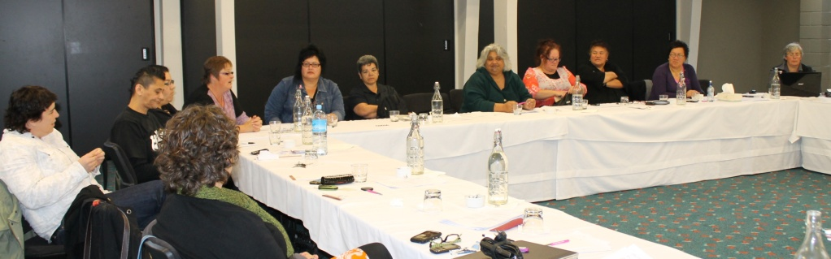
Lower North Women’s Refuge advocates take part in discussions at a Regional Hui.

Report from our Volunteer Coordinator

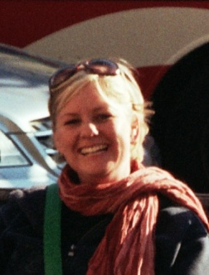
Eleanor Butterworth Volunteer and Education Co-ordinator

Wellington Women’s Refuge could not function without the dedication and skill of our volunteers. We continue to have a healthy pool of on average 20-25 incredible volunteers who not only look after the out of hours crisis line, but as part of the Wellington Women’s Refuge collective they help set the strategic direction of the refuge, contribute to overseeing finances and employment , fundraising and participating in awareness raising events.
Over the past year volunteers have provided support for women over the phone, at the hospital, during police interviews and at the safe-house. In addition to this amazing contribution volunteers have also; written submissions on the Welfare Reforms and the Family Court Reforms, participated in annual appeal as site managers and collectors, attended cultural competency training from Awa-Whenua alongside our workers, and established our first volunteer sub-committee to work alongside our volunteer coordinator ensuring needs of volunteers are met while in Refuge.
In 2011 we delivered 70 hours of initial training over 8 weeks alongside Te Whare Rokiroki, Maori Women’s Refuge, this brought through 7 volunteers for Wellington women’s refuge and 2 for Te Whare Rokiroki Maori women’s refuge. These trainings are a big time commitment and cover an extensive range of topics. Due to a much better retention of volunteers we have been able to reduce our volunteer intakes from twice to once a year. In addition to initial training ongoing supervision has been offered twice a month for the purpose of debriefing on calls and furthering training, some of the topics covered in these sessions include: Safety planning for women who stay, case study presentation from our social workers, grounding techniques for call outs and men’s programmes.

We would like to take this opportunity to say a big thank you to all those wonderful volunteers for all they give to Refuge and the women and children we serve, and also to their families and friends who are often invisible support to the Refuge cause.

Report from our Staff Support Manager

This year was once again a busy one for the Staff Support Manager and Employment Sub-committee. The role of our Staff Support Manager is vital for providing day to day support for our team of paid staff. Our social workers receive both external and internal supervision as well as support with case management. This year the focus has been on building a supportive team environment, professional development and ensuring workloads are shared as evenly as possible. We are proud of the progress we have made and the continued achievements made by our team of paid staff over the last year.

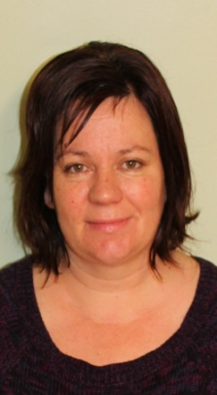
Philippa McAtee Staff Support Manager
Professional Development: We continue to support our staff to upskill and attain skills and knowledge for their work at Women’s Refuge. In addition to internal trainings our staff have attended a range of training including; resilience, child abuse prevention, and working with refugee and migrant communities. A highlight this year was two of our staff having the opportunity to attend the 2nd World Conference of Women’s Shelters in Washington DC along with a contingent of advocates from our National Collective. Meeting and talking with domestic violence advocates from around the world was a great networking opportunity and much valuable learning was brought back from the many workshops that were held. Workshops covered a wide range of topics and those attended included; safety planning and risk assessment, sustainable fundraising, working with faith-based communities, creating a management structure to support survivor and advocate safety, sheltering families and pets together, working with immigrant communities, working with LGBT communities, evaluating services, modelling a culture of wellness and feminist activism. While we were envious of the government funding available to Refuges in America we were pleased to see that we are comparable in terms of best practice and standard of services provided and that an advantage of operating on a smaller scale means we are able to retain holistic services that cater to the individual needs of those we support.

Acknowledgement to staff: Our staff carry consistently high workloads and maintain a high standard of service, while constantly juggling various roles, projects and tasks. It is only due to a lack of ongoing adequate funding that we have not been able to increase staff numbers. We would like to take this opportunity to thank each member of the team for their ongoing passion and commitment to the work that we do with limited resources in a tough economic climate.

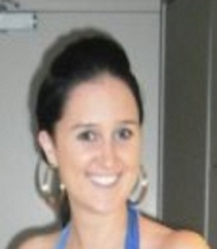
Treasurers Report

Financial Overview 1 April 2011 to 31 March 2012

Wellington Women’s Refuge recorded total income of $471,289 for the financial year 1 April 2011 to 31 March 2012. Total expenditure was $472,363, resulting in a net loss of $1,074.
We are pleased that our robust budgeting process has enabled us to stay on track with
Anna Thomson income and expenditure this year. The small loss results from a portion of a
Wellington City Council grant being allocated into the 2012 income year.
Our thanks again go to Deloitte and particularly Audit Partner Trevor Deed who again completed our audit for the year ending 31 March 2012. We are grateful to Trevor and Deloitte for their continued support of Wellington Women’s Refuge and are excited to confirm that Deloitte will continue to support us for a further two years (until the end of the 2014 financial year).

Financial Position  As at 31st March 2012  ASSETS  CURRENT ASSETS  Cash at Bank 165,891  Accounts Receivable 3,842  Investment Fund:  Gwen & Kevin Day Charitable Trust 202,426  ________  Total Current Assets 372,159  NON CURRENT ASSETS  Fixed Assets 16,986  __________  Total Non Current Assets 16,986  __________  TOTAL ASSETS 389,145  CURRENT LIABILITIES  Accounts Payable 20,661  BNZ Visa Account 1,654  Employee Entitlements 17,265  Goods & Services Tax (GST) 21,906  Grants in Advance 27,498  __________  Total Current Liabilities 88,984  __________  TOTAL LIABILITIES 88,984  __________  NET ASSETS 300,161_  Represented by: __________  GENERAL FUNDS 300,161 | Financial Performance  For the year ended 31st March 2012  INCOME  Grants  National Collective of Independent  Women’s Refuges 130,294  Lotteries 55,361  MSD Community Response 71,667  MSD Family Centred Service 65,000  Community Organisation Grant Scheme 10,000  Wellington City Council 39,500  Projects 2,567  __ _________  Total Grants 374, 389  Donations/Fundraising 71,072  Education Programmes 15,135  Rentals 4,200  Interest Received 6,493  _ _________  TOTAL INCOME 471,289  EXPENDITURE  ACC Levy 1,792  Audit & Accountancy 703  Bank Charges 292  Call Centre 6,889  Client Support 250  Depreciation 9,370  Education Programmes 2,914  Fundraising/Appeal costs 1,813  Hui Attendances & Hosting 5,921  Insurance 4,980  Interpreting 1,817  Rent 36,000  Office Costs 25,497  Safehouse 14,985  Staff Costs (incl Recruitment) 328,157  Training & Supervision 13,982  Vehicle Costs 15,412  Volunteers 1,589_  Total Expenditure 472,363  ___________  NET (DEFICIT) FOR THE YEAR (1,074)  ___________
This financial information is extracted from the full financial statements which are available on request

Treasurers Report continued

Outlook for 2013 financial year
We are even more aware of funding and budgeting for the upcoming year ending 31 March 2013. We have again completed a stringent budgeting process and have incorporated a budget review into our yearly process to enable us to substantively review income and expenditure in September/October 2012. This will assist in ensuring we remain on track for financial sustainability.

Our review of our Gwyn and Kelvin Day Charitable Trust began in the 2012 financial year and the process of transferring our investments into Gareth Morgan Investments will continue during the 2013 financial year. We are expecting our investments to yield a better return following this move and for the management of those assets to be more active and cost effective.

We continue to remain focussed on “thinking outside the box” for new ways to enhance our revenue and reduce our expenditure. The Finance Committee are working with the Annual Appeal Committee and the Fundraising Committee to ensure that projects move forward in this area.

Fundraising

In the changing economic environment we continue to put a lot of thought and energy into our funding plan. We face the challenge to meet not only the significant operating costs of our crisis and social work services but also find ways to expand our services to include a strong preventative element to our work, ensure quality services for both women and children, and be able to provide ongoing upskilling and training for staff and volunteers. These are all things we see as vital to our ongoing success and part of a strategic approach to tackling domestic violence.

Annual Appeal: this is run jointly with Te Whare Rokiroki, Maori Women’s Refuge, with the total being shared between the two Refuges. This year our annual appeal achieved a grand total of $36,000. This was a great result given the economic climate. Once again we are grateful for the wonderful support we receive from our community. Without this support we could not continue the vital work we do in the Wellington community. We would like to thank the dedicated collectors and site managers who braved the cold weather to collect for us, and to Kyla Lyons who co-ordinated the joint appeal this year and put in a lot of effort and enthusiasm to help make the event a success.
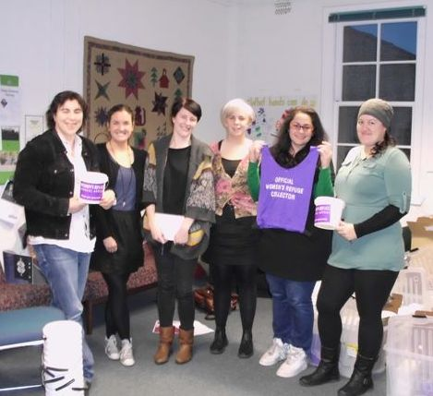
2011 annual appeal sub-committee prepare for the big day

Fundraising Sub-committee: our fundraising subcommittee is working to build on our fundraising efforts throughout the year. While our annual appeal remains our biggest fundraiser we also raised funds through taking part in a Bunnings stock take as a fundraiser, selling excess donated items at a fair and on trade-me, and receiving financial donations via ‘give-a-little’ website. Next year we hope to increase revenue with a new fundraising event being planned.

Funders and Supporters: We are hugely appreciative of our funders who keep our service going by providing funds for salaries, rent and general operating costs. We also get a wonderful amount of support from our community who support us in the form of regular donations, payroll giving and the one off cash donations from individuals, businesses, community organisations and education institutions. These make up a significant portion of our income and vital to our operation.

We would also like to thank the local businesses who donate products and services for our safe-house, clients, and fundraising events. We also receive many donations from individuals who donate furniture and quality clothing for us to gift to women and children setting up home again following abuse, money donated through payroll giving, one off donations, and bequests. We also receive support from community groups and schools fundraising for projects and services.

Acknowledgements
As a charitable organisation we depend upon donations and grants to fund our work. We would like to acknowledge the following organisations for their support.
.
Funder | Purpose | Amount
Ministry of Social Development – Family Centred Fund- Shared with Te Whare Rokiroki | Direct services to family and whanau. | $160,000
Lotteries Community Fund | This grant went towards the salaries of our Staff Support Manager and a Community Social Worker/Women’s Advocate. | $55, 361
Ministry of Social Development – Community Response Fund Round 7 | Provision of critical community based services addressing domestic violence. | $50,000
Wellington City Council | We have a 3 year partner contract with the WCC to deliver services to our clients. The above amount was put towards the staff salaries of our paid Social Workers/Community Advocates. | $20,000
Wellington City Council – Social Pool | This funding was used to contribute to the salary of our Volunteer Coordinator | $12,000
Wellington City Council Betty Campbell Grant | Funding towards office rent costs | $10,000
COGS Community organisation grants | This funding was granted towards a Community Social Worker/Women’s Advocate salary. | $10,000
Winton and Margaret Bear Trust | Funding for resources for Tamariki Programme and children in our service | $751
Graeme Eskrigge Trust | Funding for new computer for accounts and admin worker | $1520

Businesses, Individuals & Community Organisations who Support Wellington Women’s Refuge
We really appreciate the support we receive from our community. There are so many people who have assisted, supported, offered skills or resources or stood alongside us in our work. We would like to take this opportunity to offer our sincere admiration, respect and thanks to the following:
- Our dedicated, motivated, wonderful volunteers, we ask so much from our volunteers and they keep giving to this cause with so much energy and aroha. We are very grateful for everything you bring.
- All the partners, families and flatmates of our volunteers who get woken in the night by the telephone ringing, who are the invisible supporters of refuge!
- Our inspiring and skilled lawyers at Cuba Family Law who are so dedicated to working in the area of domestic violence - Margaret Powell, Wendy Davis, Liz Lewes, Fiona Miller, Kate Lash, and their support staff.
- The Wellington police force, particularly the domestic violence intervention team.
- Khandallah New World for hosting a food collection bin for our safe-house.
- Wellington City Mission – for food parcels and Christmas gifts for children.
- Our sister Refuge Te Whare Rokiroki who provide a service for Maori women in the Wellington community and moral support for Wellington Women’s Refuge.
- Doctor Helen Rodenburg and colleagues for the generosity and understanding shown to our clients.
- Both Datacom staff and Jethro Carr who have donated their time to give free I.T. support.
- Wellington Quilters Guild - for their continued donation of beautiful handmade quilts.
- Fuji Xerox - for the free printing of resources throughout the year generously supplied.
- Deloitte who once again completed our 2011/2012 financial audit pro-bono.
- Statistician Ben Ritchie for putting together our graphs for this report.
- We greatly appreciate the support we receive from the community of Wellington. The regular donations via automatic payment, payroll giving and the one off cash donations that we receive from individuals, businesses, community organisations and education institutions make up a significant portion of our income. In addition to cash donations, we receive donations of clothing, food and household goods, and other items which supplement our income.
Our final tribute goes to the women and children with whom we have worked with, and learnt from over the last year. Your strength, dignity and spirit are a constant source of courage and inspiration for us all.

Future Directions for 2012/2013

- To proceed with getting up and running our own website, improving our accessibility and information available internally and to our community.
- To continue running our women’s and children’s programmes which are a positive step in keeping safe and rebuilding for those who have experienced domestic violence.
- To increase our funding sources to ensure that we remain financially sustainable.
- Complete a structural review which will identify any gaps or issues with our current structure and look at options for solving these.
- Run an education/support session for friends and family of those experiencing domestic violence.
- Support our Pasifika social worker with establishing and strengthening relationships with the Pasifika community.
- Obtain use of a storage space for storing our donations

Did you know you can now find us on facebook?
Check out our page at:
www.facebook.com/pages/Wellington-Womens-Refuge/175339925905470

